BUILD AN EMPLOYEE TRAVEL APPROVAL APPLICATION FOR CORPORATES

# INTRODUCTION:

## Overview:

Corporate travel is an integral part of the business world, as companies need to travel to meet clients, attend conferences and meetings, and explore new markets. However, managing employee travel can be a cumbersome task for the HR and travel departments. That’s why many corporates have started using employee travel approval applications to streamline the process.

## Purpose:

The application saves time for both the employee and the travel manager by automating the travel request and approval process. The application ensures that travel requests comply with the company’s travel policies, which reduces the risk of non-compliant expenses and unnecessary travel.

# Problem Definition & Design Thinking:

* 1. Empathy map:

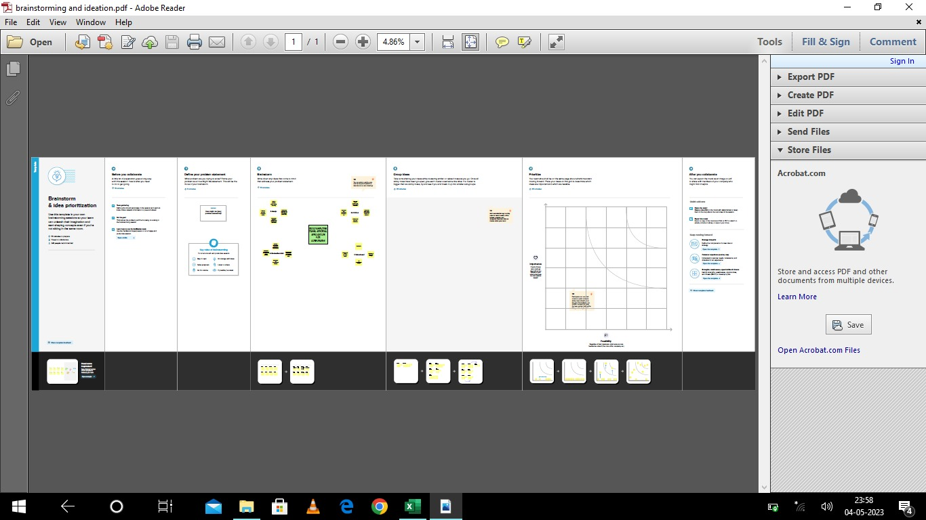

2.2 Ideation Brain storming:

|  |  |
| --- | --- |
|  |  |
|  |  |
|  |  |
|  |  |

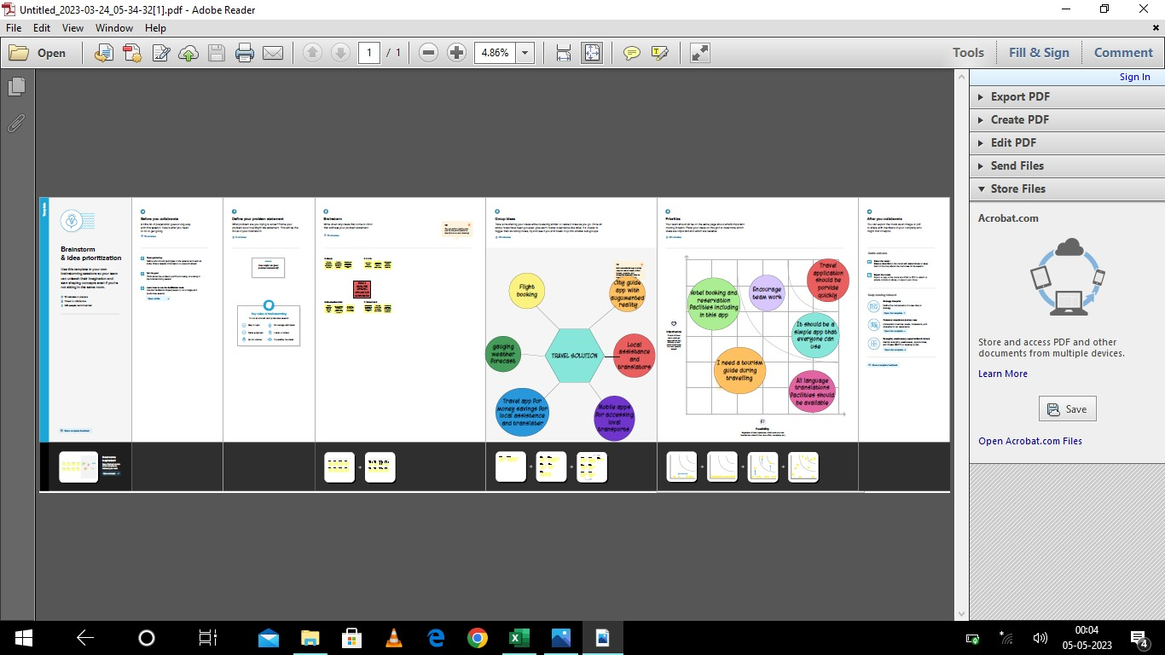

# RESULT:

* 1. Data model:

|  |  |
| --- | --- |
|  |  |
|  |  |
|  |  |
|  |  |
|  |  |

|  |  |
| --- | --- |
| Object name | Fields in the object |
| Travel Approval | Field label Data type  Enter amount currency  Expense Pick list  Travel approval Master-Detail Relationship |
| Expense Item | Field label Data type  Total Expenses Roll-Up summery  Status Indicator Formula |

* 1. Activity & Screenshot:

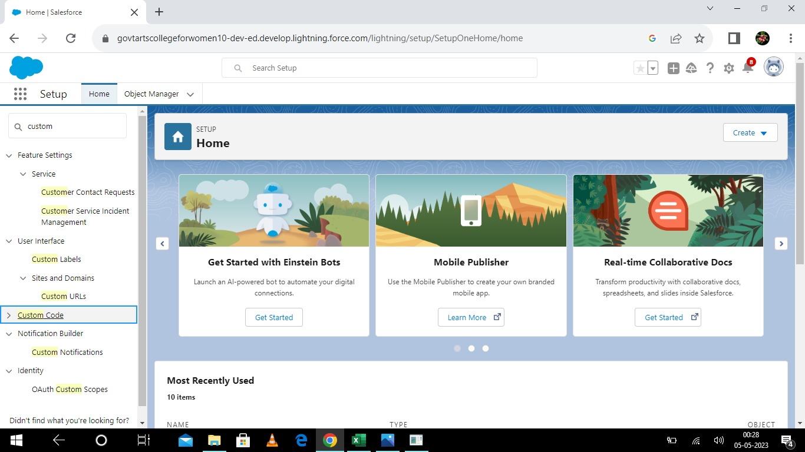

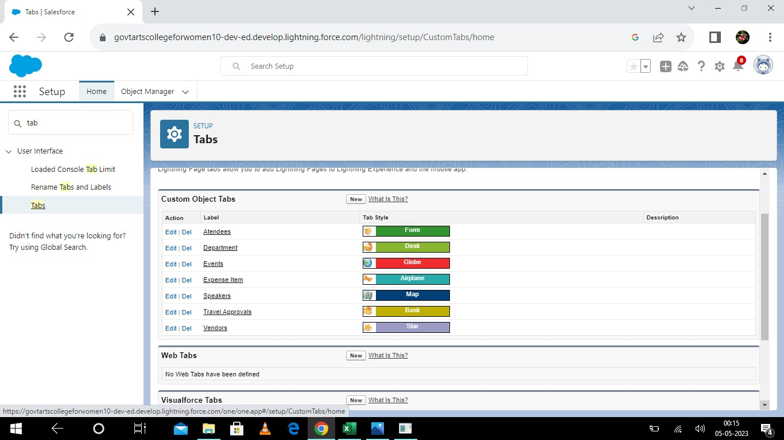

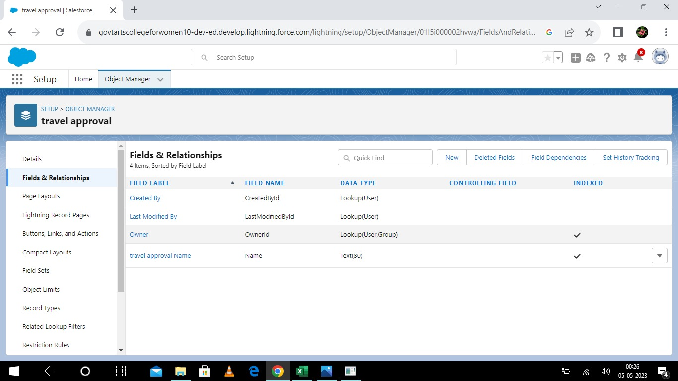

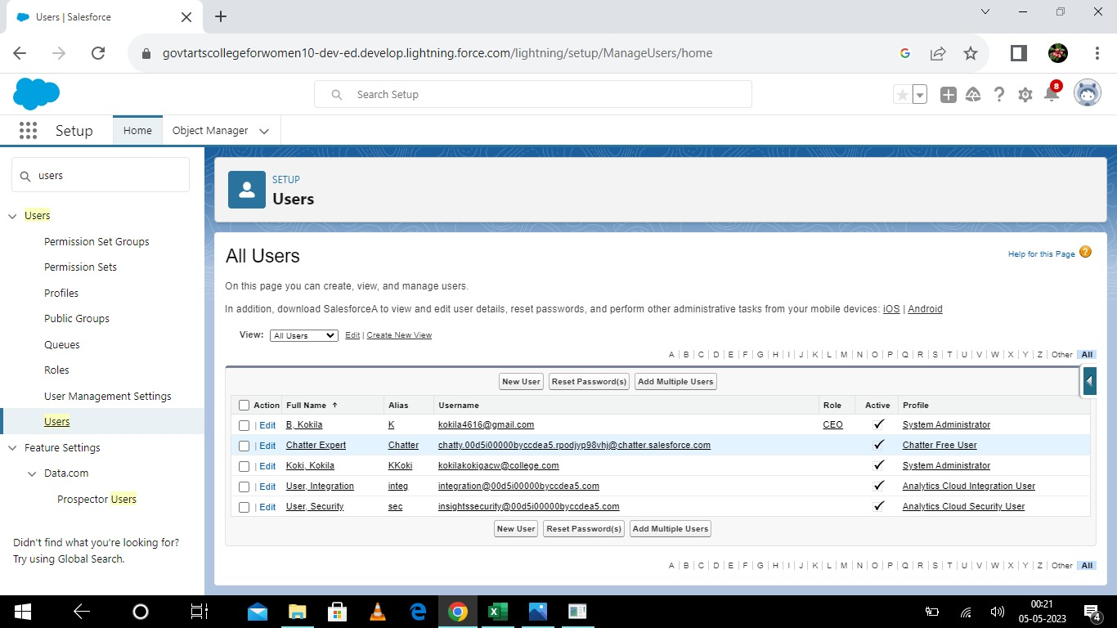

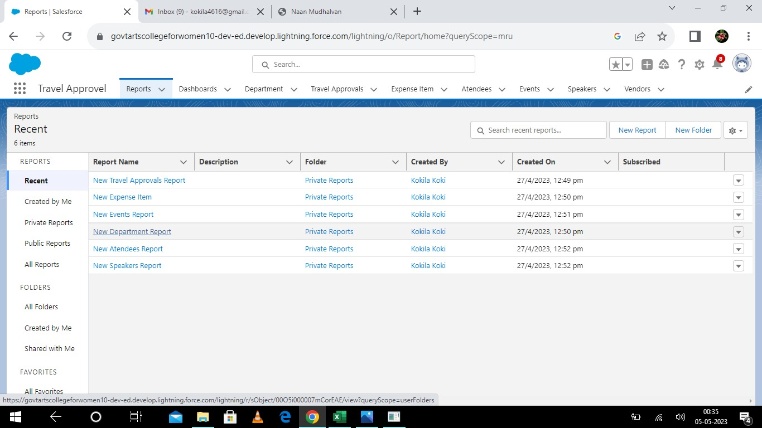

### Trailhead Profile Public URL:

Team Lead- <https://trailblazer.me/id/mmanju111>

Team Member 1- <https://trailblazer.me/id/kkoki8>

Team Member 2- <https://trailblazer.me/id/roobm2>

Team Member 3- <https://trailblazer.me/id/yokek1>

### ADVANTAGES:

* The process is tedious and time consuming task.
* Easiest way.
* Save time for both employees and managers.
* Reduces the Workload.
* Provides greater control and security over employee travel.

### DISADVANTEGES:

* The process includes too many levels of approval that make tedious and confusing.
* Regular Maintenance.
* Internet connection problem is there.
* Poor connection leads to trouble and anxiety.
* Lack of leadership.
* Poor communication.

### APPLICATIONS:

* The application ensures that travel requests comply with the company’s travel policies which reduces the risk of non- complaint expenses and unnecessary travel.
  + The application helps reduce travel costs by allowing the company to track expenses and stay within budget.
* The application saves time for both the employee and the travel manager by automating the travel request and approval process. This allows the HR department and travel managers to focus on more strategic task.

### CONCLUSION:

* An employee travel approval application is a valuable tool for corporate travel management.
* It streamlines the travel request and approval process ensures policy compliance, and provides transparency to all parties involved.
* A well-designed application can save time and money, making it an essential tool for corporate that frequently travel for business.

### FUTURE SCOPE:

* In future it will be really a useful one in the application of travel approval.
* It is trusted to be in future everyone will utilize this.
* The customer will set good service and make it trustworthy.
* Hope it would fulfil all the needs of the users.